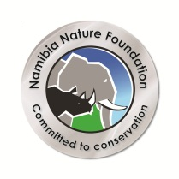 | Namibia Nature Foundation  Community Conservation Fisheries in KAZA Project  Vacancy announcement | 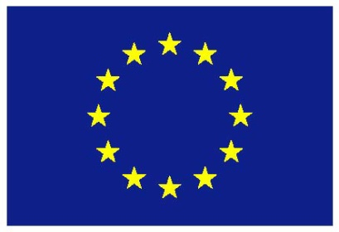

Sociological Consultancy on the Kwando River fishery
The Namibia Nature Foundation is looking to appoint a short-term consultant to conduct sociological research with the emphasis on the fishery on the Kwando River through the project titled “Improving Fishery management of the Kwando River for Sustainable Livelihoods“. This entails detailed understanding of all components around the social and economic aspects of fish and fishing activities along the Kwando River, Namibia.
- Overall Objective
NNF is one of the implementing partners of the WWF program “Sustainable Communities partnership”, which hosts a number of components to address improvement of livelihoods of communities in the area of Mudumu North and South complex. Amongst others, one component will be to address the currently challenging situation on fisheries along the Kwando area.
The project will be split into two phases:
- The planning phase
  - Frame survey
  - Draft a proposal for phase 2
- The implementation phase.

The role of this project is to support fishing communities along the Kwando River in developing community management strategies, a programme that necessitates comprehensive knowledge of the fishing communities. The Kwando River is a very sensitive ecosystem that can easily be impacted by people, especially the impact on the fish stocks. Research has indicated that this river cannot withstand intense fishing pressure and needs to be protected or well managed. The role of the Sociological Consultant is to obtain detailed information on the fishing communities as part of phase 1, in order to develop a sound proposal and inform the implementation phase.
The consultancy should address the following questions:
- What is the contribution of fisheries to their livelihoods, are the fisheries managed, if so is it on a regional, local or village level?
- Is the fishery mainly for subsistence or is there a commercial side of the fishery?
- Has there been any change in the fishing activities over the years?
- What is the community structure of the fishing community, i.e. provide a thorough description of the inter-relationships between all stakeholders?
- Are there any fisheries committees, if so how do they operate and what challenges do they face?
- How representative are these committees of the fishing communities they represent?
- Is there any trading of fish, what are the markets?
- Do they have any knowledge about the Inland Fisheries Legislation?
- Would they prefer any support either from government, NGOs or the private sector?
- Should the fishery be managed in their area?
- What role does the lodges play in relation to the fishery and fishing communities?
- Is there any influx from outsiders entering the fishery and how is this affecting the local communities, especially related to the fishery and the management approaches?

The consultant will liaise closely with the NNF Project Manager and Project Co-ordinator and will submit a comprehensive report and will advise on the development of a detailed project proposal on the potential management of the fisheries on the Kwando River emanating from the results of the study. Specific areas to be targeted will be identified.

- Key duties and responsibilities for the Sociological Consultant:
- Familiarise with the methodology of a frame survey for fisheries
- Undertake a field trip to do a frame survey, assessing the socio-economic situation around fisheries in the conservancies Kwando, Mayuni, Mashi and Balyerwa
- Discuss with feasible communities their interest to engage in improved fisheries management
- Prepare a report on the findings of the field trip, outlining recommendations for the implementation phase
- Based on the findings of the frame survey and in line with the overall objective of the WWF program, develop a proposal for the implementation phase.

- Time Frame: the total number of days estimated for this consultancy is 30 days. The consultancy is expected to start in July 2017 and finalise end of August 2017.

- Desired qualifications and experience:
- Postgraduate degree in sociological and/or environmental science.
- Proven ability to conduct community-based surveys and the production of well written reports.
- Minimum 10 years experience in community-related, natural resource management projects, including extensive understanding of community/village/conservancy structure and organisation, in the Zambezi Region, especially the Kwando area.
- English speaking, plus ability to operate effectively with interpreter.
- Additional preferred knowledge, skills and abilities
Familiarity with issues surrounding fisheries management of the Zambezi Region’s rivers and lakes.

- Submission of Application
Interested candidates should apply by email to Ms Irene Brendell at the NNF Office in Windhoek.
Candidates should submit their CV with an accompanying email that clearly states how their skills and experience meet the requirements of the position. References should be available on request as well as copies of certificates. Applications must be submitted by 30 June 2017. Daily rates must be indicated as well as the terms and conditions (including/excluding VAT).
Only short-listed candidates will be contacted.
This document has been produced with financial assistance of the European Union. The contents of this document are the role responsibility of NNF and can under no circumstances be regarded as reflecting the position of the European Union.

